**UTAH'S GREEN RIVER COMPLEX CALLED "NEW AREA 51"**   
  
**ACTUAL PROSPECTS OF THIS BEING SO SEEM SLIM**

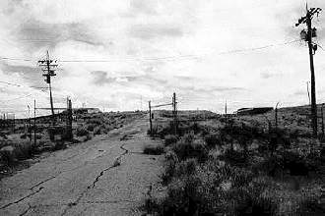

**THIS REPORT WAS REPRODUCED FROM THE CLUI.ORG WEBSITE**

A remote Army facility in eastern Utah was called "the New Area 51" in Popular Mechanics Magazine's June cover story. According to the magazine, the Green River Complex, along with Michael Air Field at Dugway Proving Ground, may become an aviation test complex, replacing the overpublicized Groom Lake base known as "Dreamland" and "Area 51." Though based on limited evidence, the claim has increased interest in the Green River Complex, sufficient to warrant a characterization of the facility in these pages.

Officially called the Utah Launch Complex, the 3,650 acre site in the bare hills north of Moab, was established in 1961 as a launch point for test missiles bound for the Army's 4,000 square-mile White Sands Missile Range, in New Mexico. The site has been in "caretaker status" since the last launch in 1974, and has fallen into disrepair. It seems to be an unlikely candidate for a new classified defense project site, as was discovered by field researcher Doug Denk, reporting to the Area 51 Research Center:

It didn't take a whole lot of searching to find the place, which is located next to Interstate 70, about six miles east of the town of Green River, Utah. To get there, simply get off I-70 at exit 162, and head south (away from town). You will immediately come to a "T" intersection. Turn left and you're on the main drag of the Green River Launch Complex.

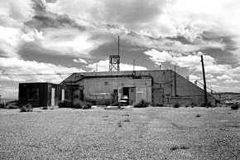

**THE BIG BUNKER AT THE GREEN RIVER COMPLEX - PHOTO BY DOUG DENK**

The facility itself, officially referred to on signs here as the Utah Launch Complex, sits in a shallow valley roughly four miles long east-west and one mile wide north-south. It consists of a total of ten significant buildings and structures scattered throughout the valley, with a few other old foundations and poles here and there. Overall, the complex is in a terrible state of disrepair. Signs are unreadable, windows are boarded up, and most buildings are visibly damaged in some way. The power lines to all the buildings I inspected had been smashed to bits.

Starting on the west side of the complex, at the "T" intersection mentioned above, and heading east up the main drag, the complex is laid out like this: After about 0.5 miles, there are three large, grey metal buildings on the right. These are completely fenced off, and are labeled as the Magazine Area. These buildings sit only about 200 yards south of I-70, and are plainly visible from the freeway.

At 2.2 miles is the intersection of Crystal Geyser Road with the Meteorological Building (as indicated by a sign out front) just to the south. The building is completely empty and in sad shape. Continuing on the dirt road to the south leads through some low hills and then south west to the geyser and the east bank of the Green River. North on Crystal Geyser Road heads past a communications tower, on a hill to the east, then under the interstate.

At the end of the main drag, at mile 3.3, is the launch part of the complex, with five major structures. It is encircled by a chain-link and barbed-wire topped perimeter fence, and is hidden from immediate view from I-70 by some hills to the north. The gate into the main complex is usually wide open, and there are no legible "No Trespassing" signs anywhere in the area.

At the center is a bunker-type, concrete and earth structure. Immediately behind the bunker is what appears to be one of the launch sites, now only a concrete slab with metal rails along its length. A couple hundred yards south of the bunker is the largest building in the complex, known to be the former device assembly building. Also in this main complex area is a large shed or garage, and a collapsed tower.

I could find no signs of any recent activity, anywhere on the site, in fact, the place looks utterly abandoned. In the four or five hours I spent examining the site, I never saw another person.